Contents
1. What is N+1 query problem? How to solve them? 2
2. How does Hibernate manage transactions? 2
3. Entity lifecycle states in hibernate. 3
4. Suppose you need to send a Java object over a network in a distributed application. What challenges might arise, and how would you handle them 3
5. Explain Garbage Collection in JVM. and it's algorithm. 6
6. Different ways of caching and how to implement caching in spring? 7
7. What is LRU cache, and which types of cache is it? 7

What is N+1 query problem? How to solve them?
Resources: https://medium.com/databases-in-simple-words/the-n-1-database-query-problem-a-simple-explanation-and-solutions-ef11751aef8a

How does Hibernate manage transactions?
Programmatic Transactions in Hibernate
In programmatic transaction management, the developer explicitly controls the transaction boundaries using Hibernate’s Session and Transaction APIs. This means you manually start the transaction, perform database operations, and then either commit or roll back depending on whether the operations succeed or fail. This approach gives fine-grained control but results in more boilerplate code.
Example:
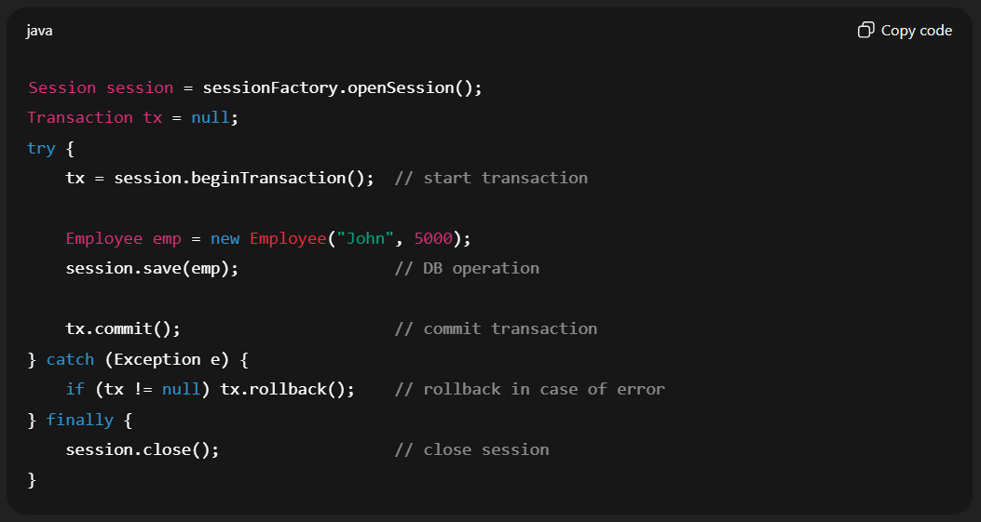
Here, Hibernate internally delegates transaction handling to the underlying JDBC connection.
Declarative Transactions in Hibernate (with Spring)
In declarative transaction management, transaction boundaries are managed by the framework (e.g., Spring) instead of the developer writing explicit code. You declare transactional behavior using annotations like @Transactional, and Spring’s transaction manager automatically handles opening, committing, and rolling back transactions. This reduces boilerplate code and makes the code cleaner and easier to maintain.
Example:
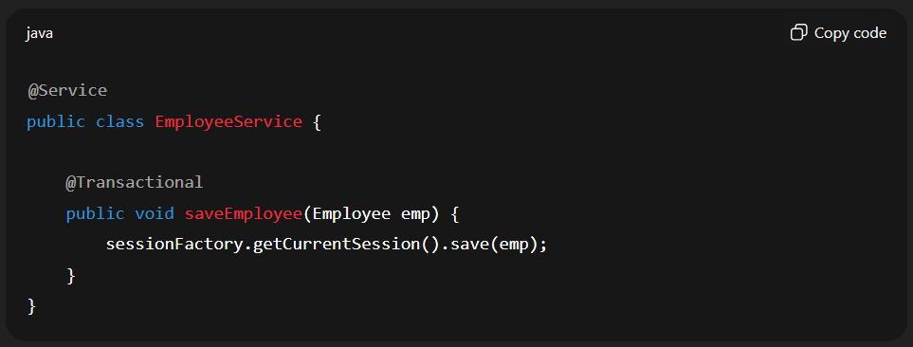
In this case, the developer does not explicitly start or commit a transaction. The @Transactional annotation tells Spring to manage the transaction automatically — if the method completes successfully, the transaction is committed; if an exception occurs, the transaction is rolled back.

Entity lifecycle states in hibernate.
Resources: https://www.geeksforgeeks.org/advance-java/hibernate-lifecycle/

Suppose you need to send a Java object over a network in a distributed application. What challenges might arise, and how would you handle them
Challenges in Sending Java Objects over a Network
1. Serialization and Deserialization
Java objects cannot be directly transmitted over the network since they exist in memory as complex structures with references. To send them, they must first be serialized into a byte stream. On the receiving side, this stream must be deserialized back into an object. The challenge arises when both sender and receiver need the same class definition; otherwise, errors like ClassNotFoundException or InvalidClassException occur.
2. Performance Overhead
Java’s default serialization mechanism (Serializable) is slow and produces large payloads. In distributed applications where thousands of requests are made per second, this can increase latency and degrade performance. Larger objects also lead to higher CPU usage and network congestion.
3. Compatibility Issues
When an object’s class structure changes, previously serialized objects may no longer be compatible. For example, adding or removing fields can break deserialization unless proper versioning is handled. In Java, this is typically managed with a serialVersionUID, but in distributed systems, maintaining backward compatibility becomes a significant challenge.
4. Security Concerns
Java native serialization can be exploited for deserialization attacks. Attackers may craft malicious byte streams to execute arbitrary code on the receiving system. Without proper safeguards, transmitting serialized objects over the network can expose critical vulnerabilities in your application.
5. Complex Object Graphs
Objects in Java often contain nested objects or even circular references. During serialization, such structures can cause inefficiencies, excessive memory usage, or even errors. Managing these deep or cyclic object graphs is another challenge while transmitting objects across services.
6. Language Interoperability
In distributed applications, systems are often built using different programming languages. Java’s native serialization is not compatible with non-Java clients, which makes it unsuitable for polyglot environments. A standardized format such as JSON, Avro, or Protobuf is required to ensure smooth communication across languages.
Solutions and Best Practices
1. Use Standard Serialization Libraries
Instead of relying on Java’s default serialization, use efficient and widely supported formats. JSON (using Jackson or Gson) is human-readable and cross-language, while Protobuf and Avro offer compact, faster, and schema-based serialization that works across multiple programming languages.
2. Ensure Backward Compatibility
When classes evolve, serialization should still work with older versions. In Java serialization, this can be managed using a serialVersionUID. For JSON or Protobuf, schema design should support optional or default values to handle new or missing fields gracefully.
3. Avoid Sending Large Objects
Sending entire object graphs can be costly. Instead, use Data Transfer Objects (DTOs) to send only the necessary data. Additionally, applying compression techniques such as GZIP before transmission can reduce payload size and improve performance.
4. Secure Serialization
To prevent deserialization vulnerabilities, avoid using native Java serialization whenever possible. If you must use it, restrict the types of classes that can be deserialized by implementing validation or whitelisting. Using safer alternatives like JSON or Protobuf reduces the risk of remote code execution attacks.
5. Handle Cross-Language Scenarios
In distributed systems where services are written in different languages, use serialization formats that are universally supported. JSON is the simplest option, but for high-performance systems, formats like Protobuf or Avro provide efficient cross-language interoperability.

Real-World Analogy
Sending a Java object over the network is like mailing a set of documents. Serialization is the process of packing them neatly into a box, while deserialization is unpacking them at the destination. If the receiver does not use the same filing system (class definition), they may not understand the contents. Similarly, if you send the entire office instead of just the necessary files (object graph vs DTO), the process becomes inefficient and expensive.
Summary
When transmitting Java objects over a network, the main challenges are serialization, performance overhead, compatibility issues, security risks, handling complex object graphs, and interoperability across different languages. The best practices include using standardized serialization libraries (JSON, Protobuf, Avro), ensuring backward compatibility, sending lightweight DTOs, securing deserialization, and adopting language-agnostic formats for distributed applications.
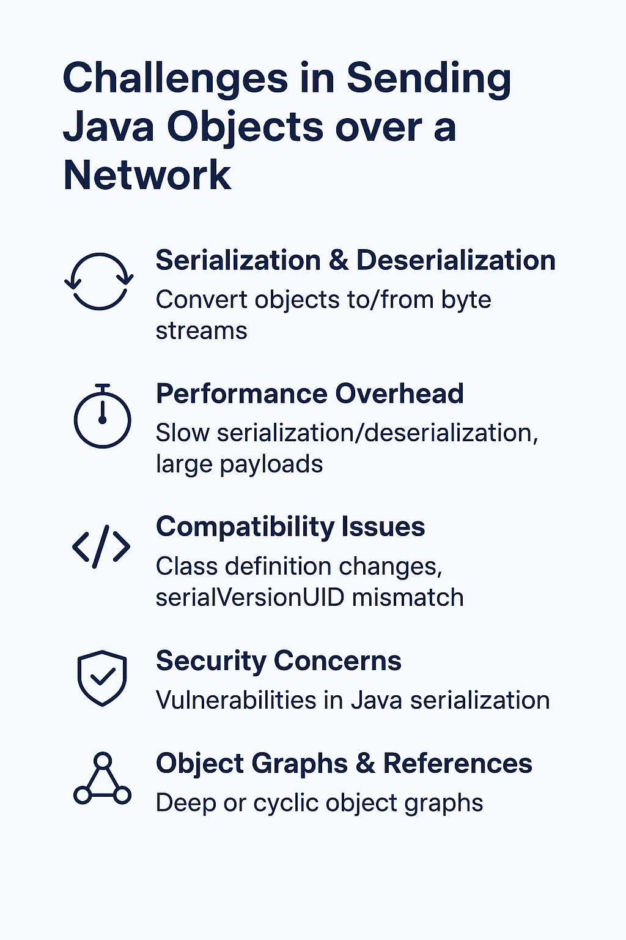

Explain Garbage Collection in JVM. and it's algorithm.
In Java, Garbage Collection (GC) is the process of automatically reclaiming memory occupied by objects that are no longer reachable (i.e., no active reference from the application).
This prevents memory leaks and ensures efficient memory usage without requiring explicit free() calls like in C/C++.
Garbage Collection Algorithms in JVM
Different algorithms are used depending on the memory region (Young Generation, Old Generation, Metaspace):

1. Mark and Sweep
- Mark Phase: Traverses object graph starting from GC Roots and marks all reachable objects.
- Sweep Phase: Deletes all unmarked (unreachable) objects.
✅ Simple, but causes memory fragmentation.

2. Copying (Used in Young Generation – Minor GC)
- The heap is divided into two regions: From-Space and To-Space.
- Live objects are copied from one space to another, and the old space is cleared.
✅ Eliminates fragmentation.
❌ Copying overhead if many objects are alive.

3. Mark-Compact (Used in Old Generation – Major GC)
- Similar to Mark-and-Sweep (marks reachable objects).
- Instead of leaving gaps, it compacts live objects to one end of memory.
✅ Reduces fragmentation.
❌ More time-consuming than copying.

4. Generational Garbage Collection
The JVM uses the Generational Hypothesis:
- Young Generation: Most objects die young (short-lived). Uses Copying GC for fast collection.
- Old Generation: Objects that survive multiple GCs are promoted here. Uses Mark-Compact.
- Metaspace: Stores class metadata (since Java 8, replaced PermGen).

5. Concurrent Mark-Sweep (CMS) (deprecated after JDK 14)
- Runs GC concurrently with the application threads, reducing stop-the-world pauses.
- Uses mark-sweep but without compaction.
✅ Low pause time.
❌ Fragmentation and CPU overhead.

6. G1 Garbage Collector (Default from Java 9 onwards)
- Heap divided into regions instead of fixed Young/Old spaces.
- Performs incremental GC with "pause-time goals".
- Uses mixed collection (collects both Young and Old regions together).
✅ Predictable low latency, avoids fragmentation.
✅ Great for large heaps (>4GB).

7. ZGC & Shenandoah (Java 11+ & Java 12+)
- Low-latency collectors designed for very large heaps (TBs of memory).
- Perform almost all GC work concurrently.
✅ Pause times usually <10ms.
✅ Suitable for real-time systems.

Summary
- Mark & Sweep → Basic GC.
- Copying GC → Used in Young Gen (fast).
- Mark-Compact → Used in Old Gen (avoids fragmentation).
- CMS → Concurrent, but deprecated.
- G1GC → Default, region-based, balanced performance.
- ZGC / Shenandoah → Ultra-low latency for large heaps.

Different ways of caching and how to implement caching in spring?
Resources: https://medium.com/vedity/spring-boot-caching-mechanism-8ef901147e60

What is LRU cache, and which types of cache is it?
LRU Cache (Least Recently Used Cache)
Introduction
An LRU (Least Recently Used) Cache is a type of cache that follows an eviction policy based on usage frequency. When the cache reaches its maximum capacity, it removes the least recently accessed item to make space for new data. This approach assumes that items that were recently used are more likely to be accessed again, while the least recently used items are less important and can be discarded.
How LRU Cache Works
Each time an item is accessed, it is marked as recently used. When new data is inserted into a full cache, the system identifies the least recently accessed entry and removes it. This ensures that the cache always holds the most relevant and frequently used items. Internally, an LRU cache can be efficiently implemented using a HashMap combined with a Doubly Linked List, which allows constant-time operations for both insertion and retrieval. In Java, this behavior can also be achieved using the built-in LinkedHashMap with access-order enabled.
Type of Cache
LRU Cache is not a cache provider itself but rather an in-memory caching strategy. It belongs to the family of cache eviction policies that decide which items should be removed when the cache is full. Many popular caching libraries and frameworks, such as EhCache, Caffeine, Redis, and Guava, provide built-in support for LRU-based eviction.
